Questions | Responses | More Information
Name | 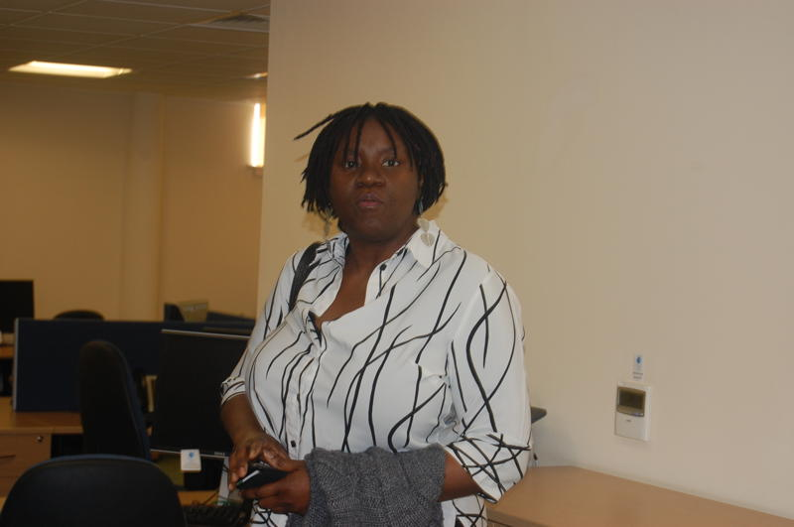  Arinola Araba (MBBS MSc) | 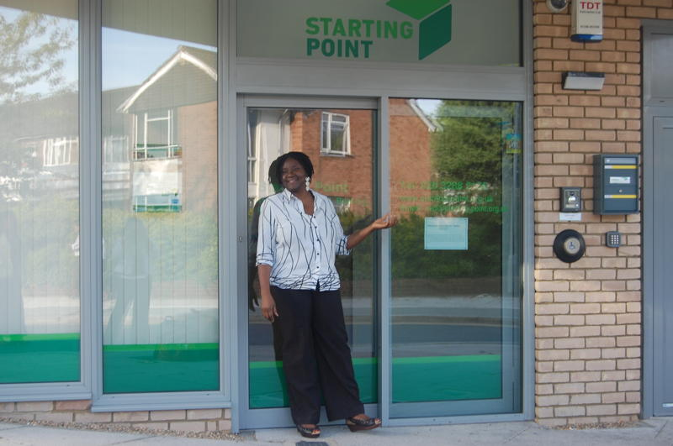
Business Name  Course / Project Name | Teach Forex Ltd  Mon£y Wi$e, Learn Money, | 
Course Content | Savings and ways to save, Budgeting, Interest rates. More here
Mission statement | To raise the level of financial literacy amongst young parents in Barking
Purpose of business/organisation | - Increasing the number of young parents who have savings  - Helping low-income groups to build savings, as a way to help combat poverty and develop future personal autonomy through fun & planned interactive workshops.  - To introduce the concept of speculative investing. To demonstrate how to invest in stocks, shares and foreign currency (forex) | 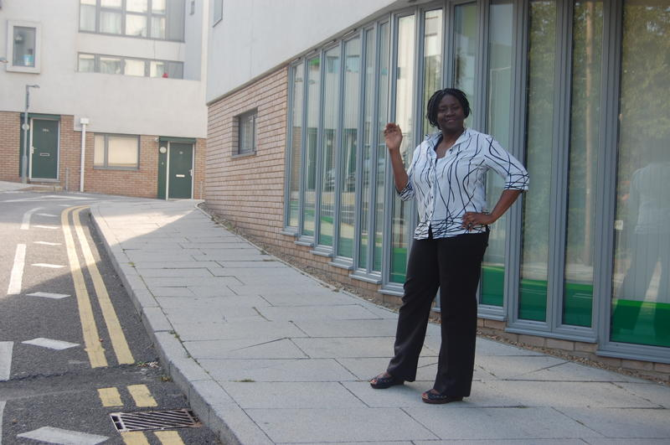
A little bit about yourself.... | I am mum to 3 exciting kids (2 teenagers) who keep me inspired. I enjoy swimming, writing and designing teaching courses. I also enjoy music, singing, IT, Management, Politics and Finance. | Some qualifications: MBBS, MSc Medical Informatics, Project Management, First Aid, Mastering Audit, ECDL, Management.  Make the Most of Your Money - FSA
What you do now in your business | I create and teach financial educational materials for 2 groups and will be presenting more workshops on “Learn Money” and Money Wize starting from April 2011 to  - Low income groups, single/ young parents  - Groups with disposable income looking to invest their money for a good return
What you hope to achieve with your project | To increase the number of debt-free low income groups who have an effective savings plan and or investment vehicle.
Business Website:  Contact telephone no  Contact Email  Contact Fax  Voicemail | www.teachforex.co.uk, www.bmoneywize.co.uk  07940 595 273  admin@teachforex.co.uk  020 3288 2101  020 3288 2233 | Please note landline contact number is for voice mail only. I am usually available by mobile.
 | Why not ask about a FREE 1:1 consultation?

